Table Creation (DDL Operations)
StudentID1:23-52178-2 Name:Md.Rafayet Hossain Zanith | StudentID3: 23-52194-2 Name:Zannatul Sharif Sabiha
StudentID2: 23-50408-1 Name:Samia Sharmin Lima | StudentID4: 22-48088-2 Name:Masrufa Sarower Tanjila
CO4: Creating DML, DDL using Oracle and connection with ODBC/JDBC for existing JAVA application
PO-e-2: Use modern engineering and IT tools for prediction and modeling of complex computer science and engineering problem |  | Marks

At first we created by using DDL with create table command in this command we
gave attributes their size and data type and also used constraint like not null,primary key, foreign key etc. then by using alter we altered FK’s into the table to connect with remaining tables.We repeated the same process for all the remaining tables.

1.MACHINE TABLE CREATION:
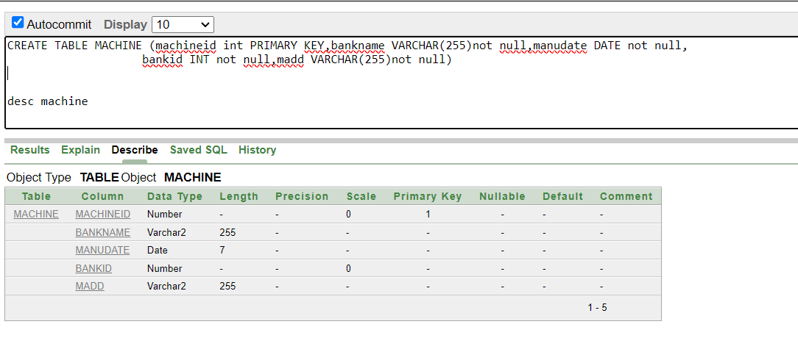

2.Machine adress table creation

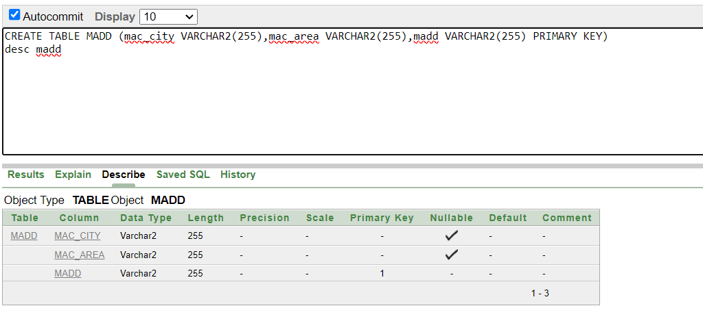

3.Bank phone number table creation

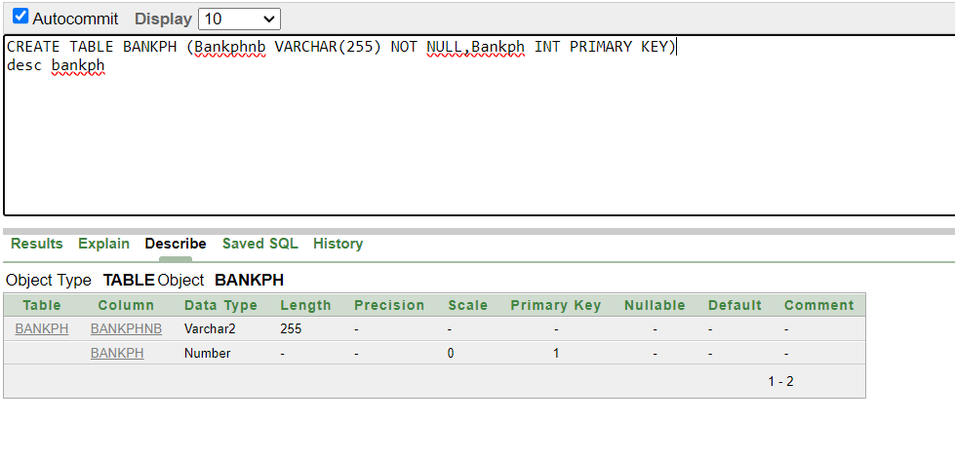

4.BANK TABLE CREATION:
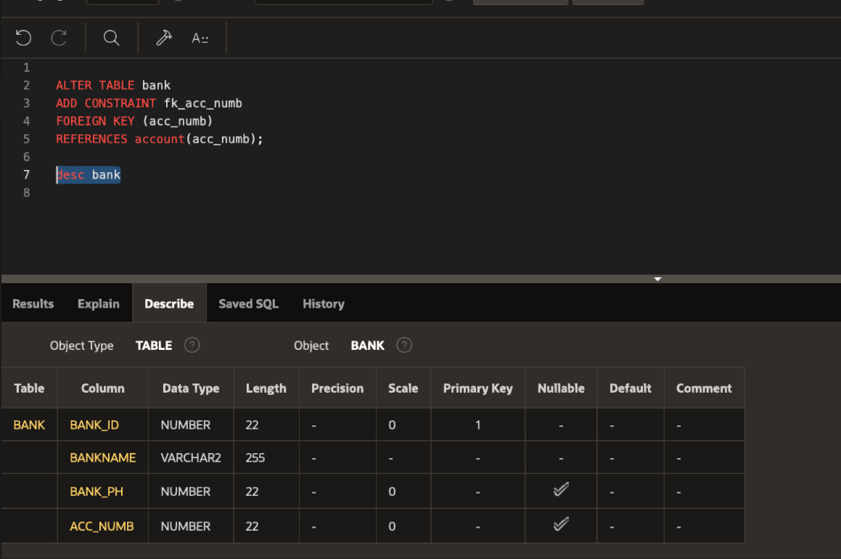
5.ACCOUNT TABLE CREATION:
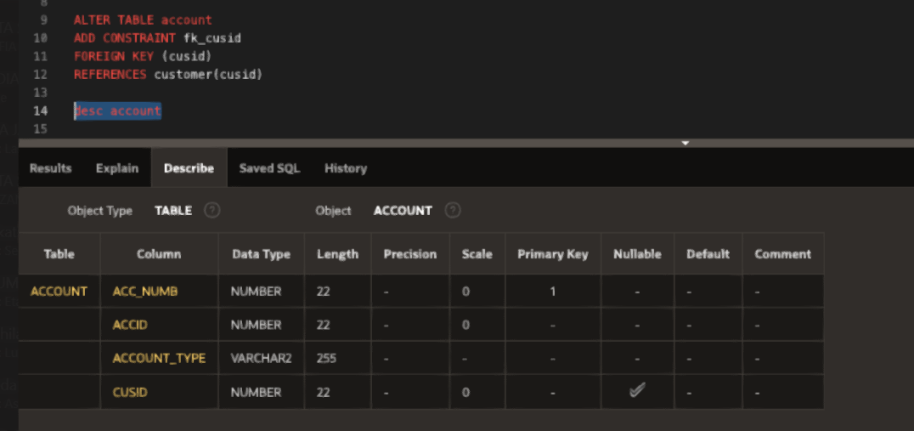

6.CUSTOMER TABLE CREATION:
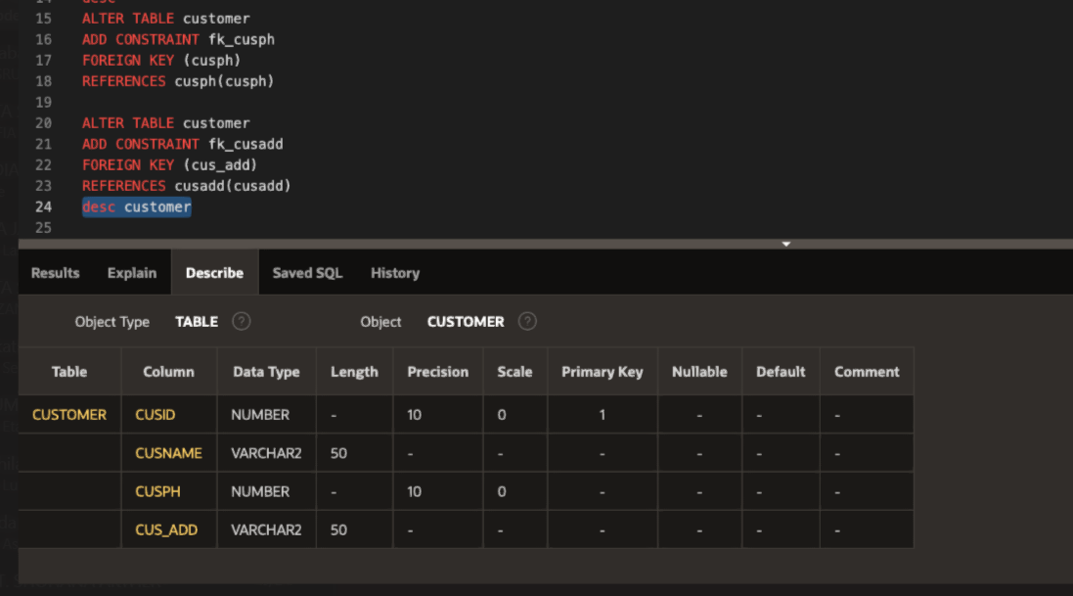

7.CUSPH TABLE CREATION:
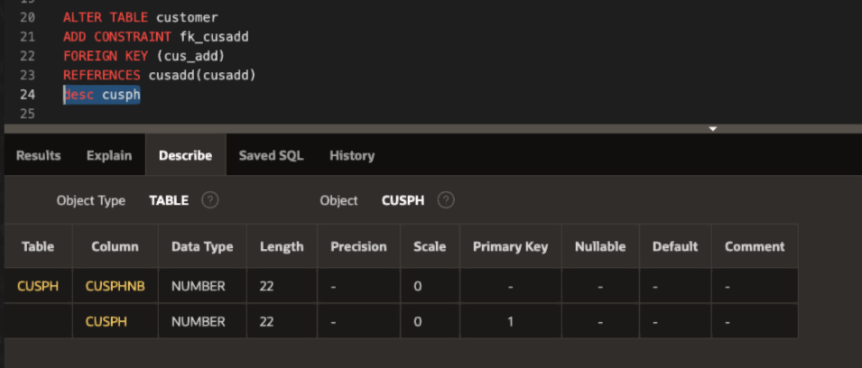

8.CUSADD TABLE CREATION:
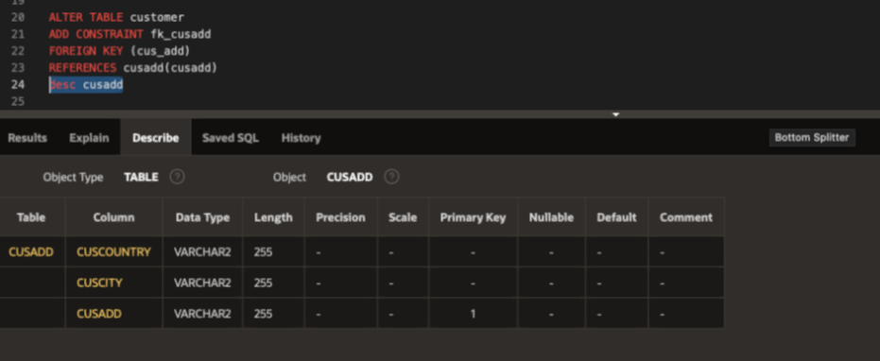
9.CID TABLE CREATION:
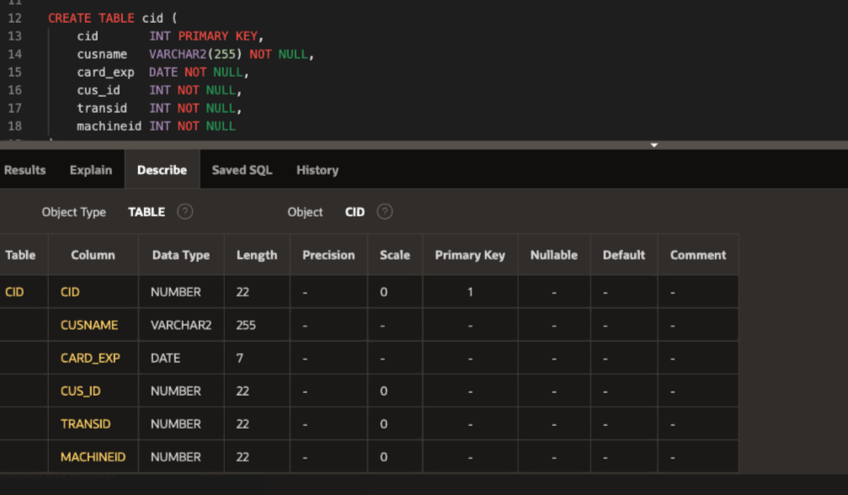

10:AMOUNT TABLE CREATION:
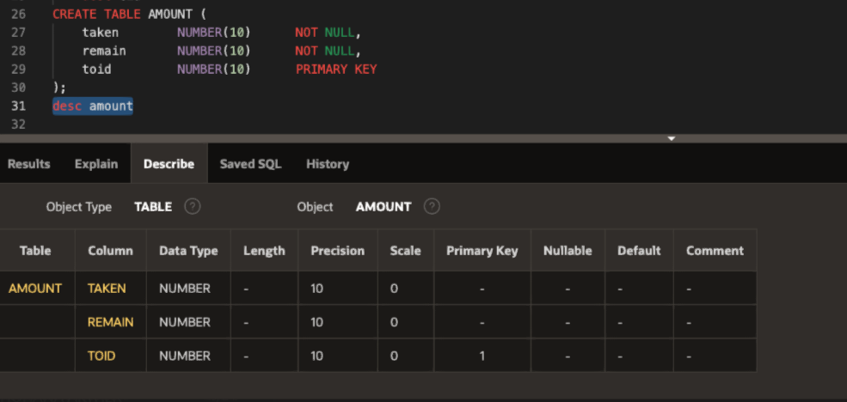
11. TRANSATION TABLE CREATION:
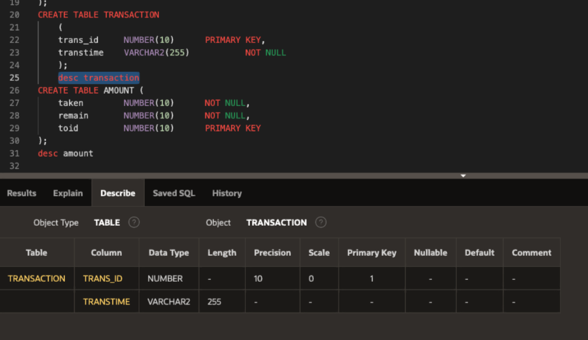

12.RECEIPT TABLE CREATION:
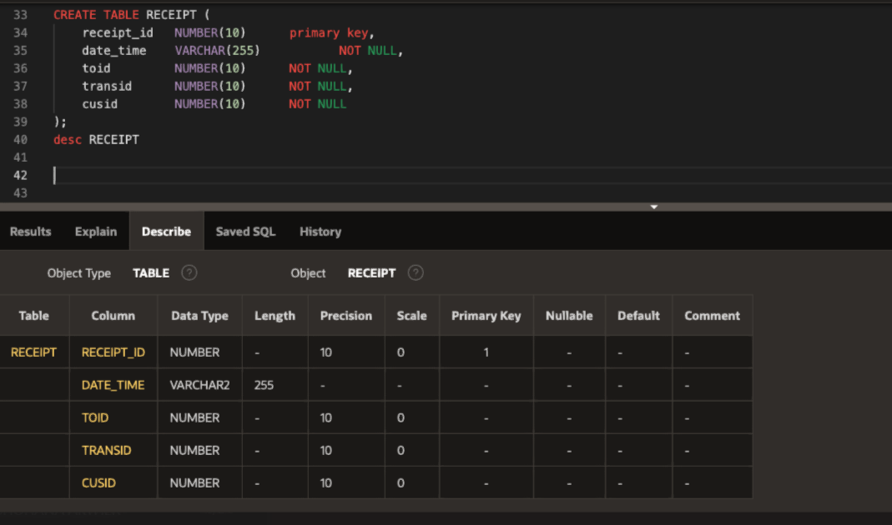
13.TECH TABLE CREATION:
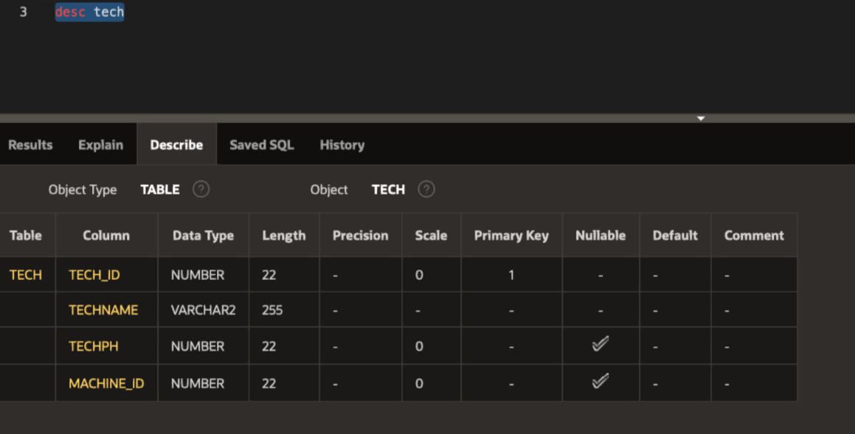
14.TECHPH TABLE CREATION:
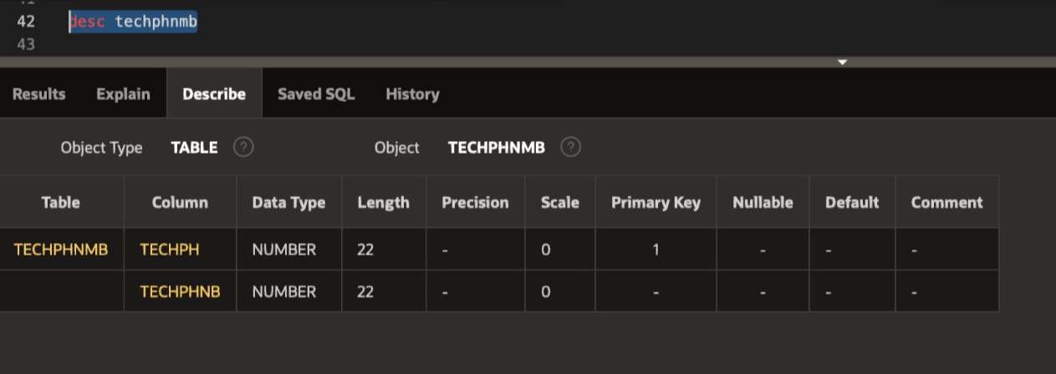

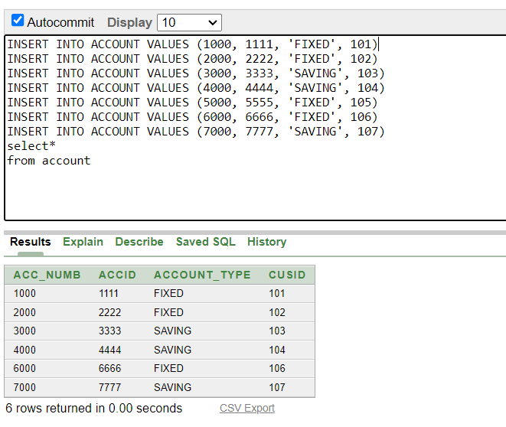
INSERT TABLE VALUES:
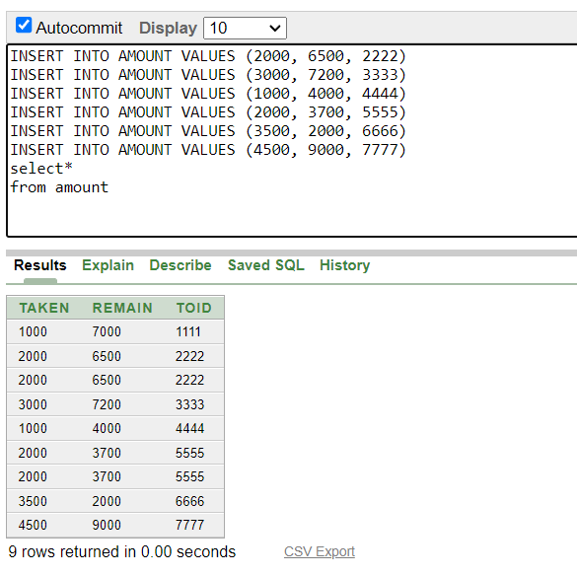
After creating the table we inserted the values to the table by using DML operation of insert .

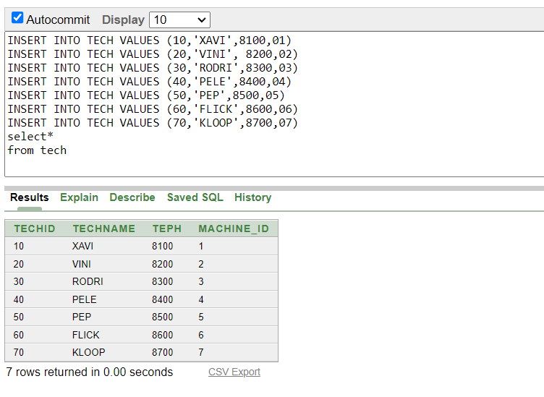
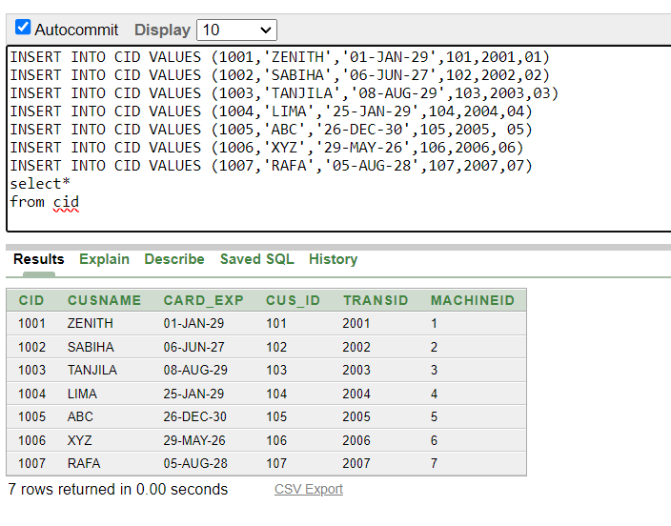
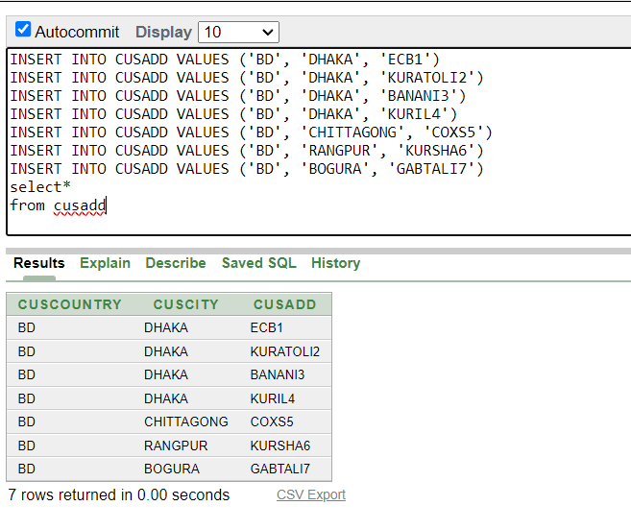
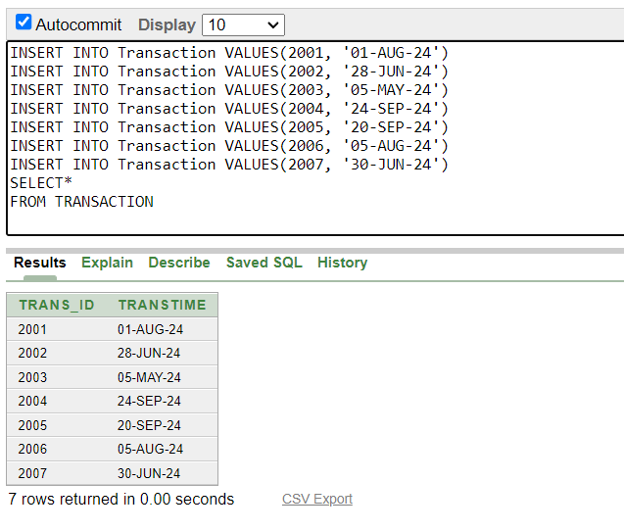
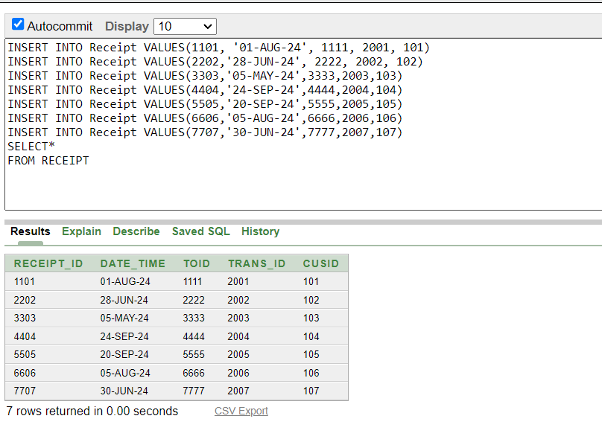
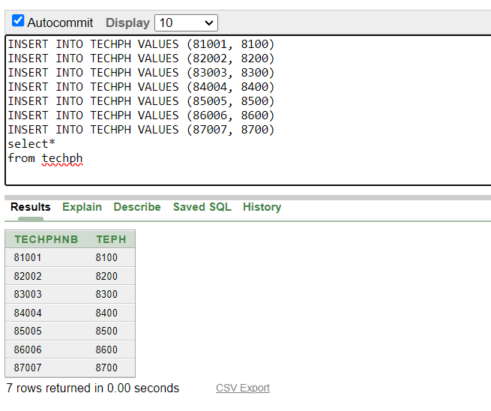

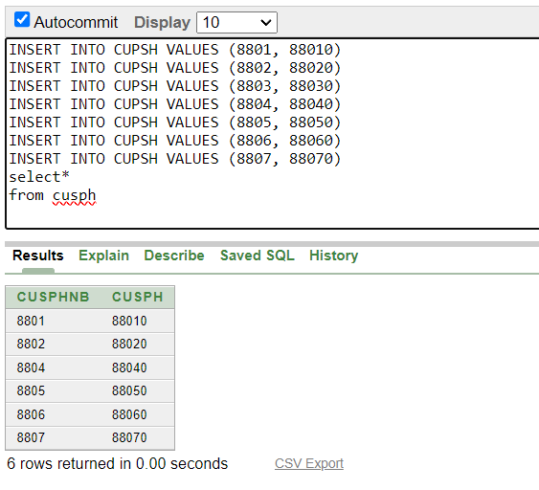
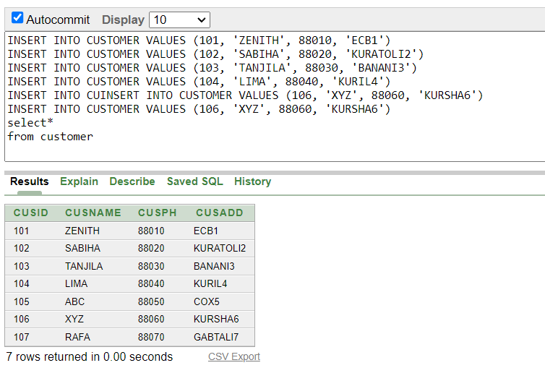

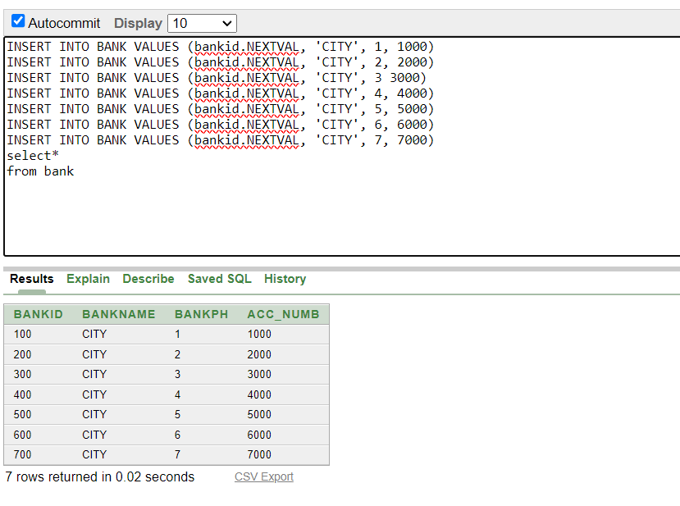
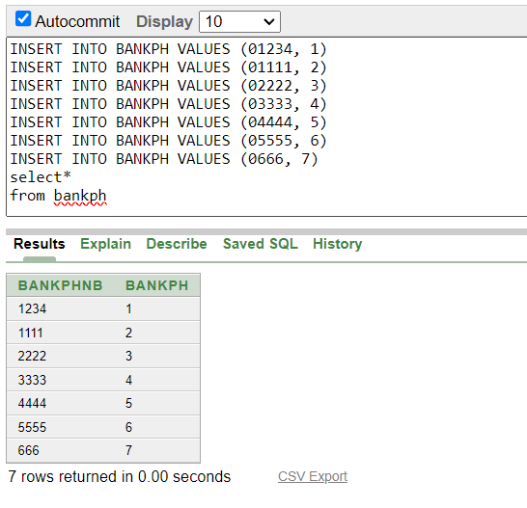

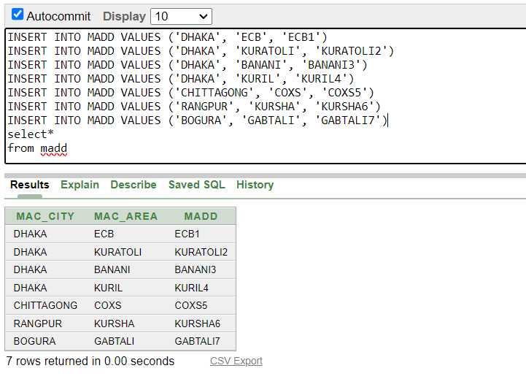
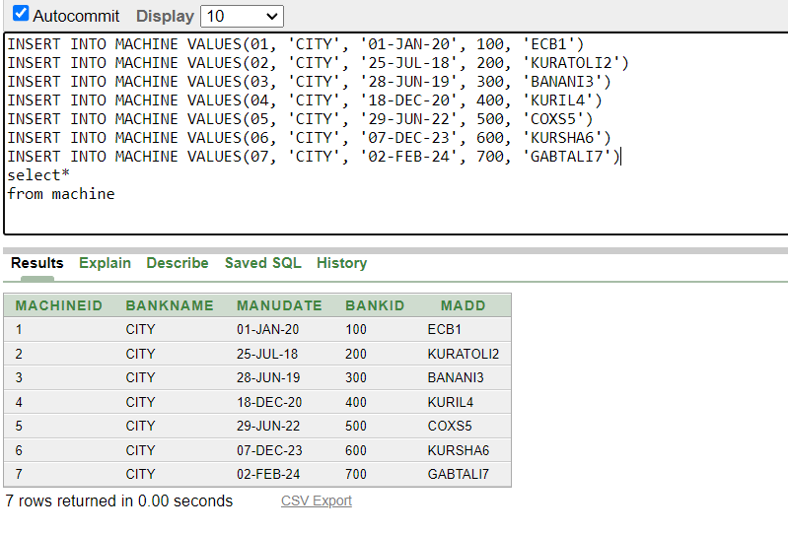

Inserted Values in the tables
## Give the screenshot of all the created tables in Oracle. All the tables should be attached one by one.t in DB
## There will be one simple query. One with Group/ Aggregate function, 2 single row Subquery, 2 Multiple Row subquery, 4 different type of joining.
- simple query
- Query with a single row function
- Query with a Multiple row function/ aggregate function
- 2 Single row subquery and 2 multiple row subquery
- 4 kinds of joining
1 simple view
1 complex view
## Provide query first, next the command for the query and at last the output:
In the end show a simple view and a Complex view:
Demo of a simple view is given below:

- Write a sql query to find phone number,named ABC from Customer table.
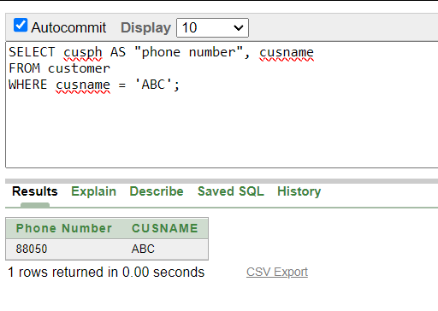
- Write a sql query to find unique bankname,number of banks.
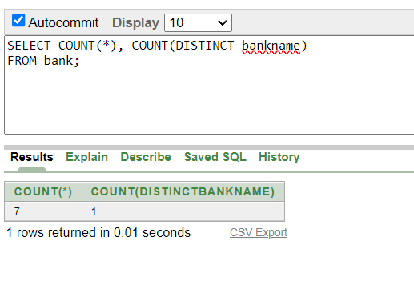
- write a sql query to find out all the banks whose name start with C.
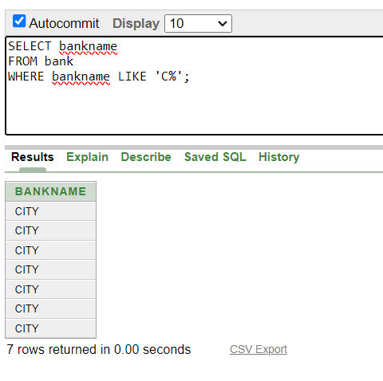

- Findout the token number who have taken more money than token number 2222 from their account through atm.
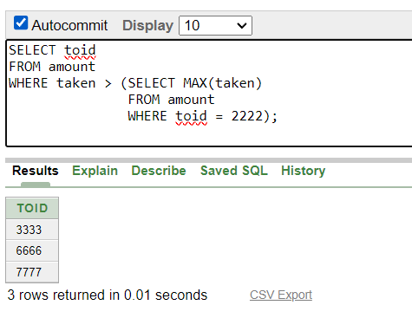
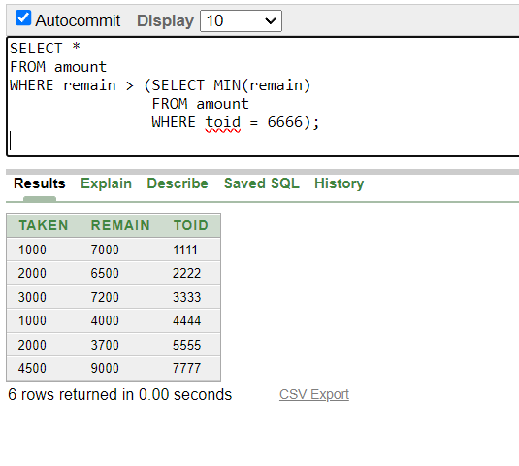
- Findout the token number who have more remaining money than token number 6666 in account.
- Select all the token id who have more than remaining money than token id 6666.
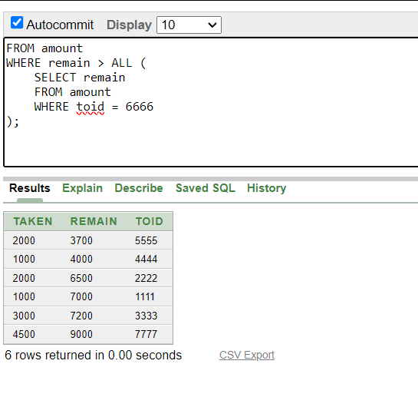
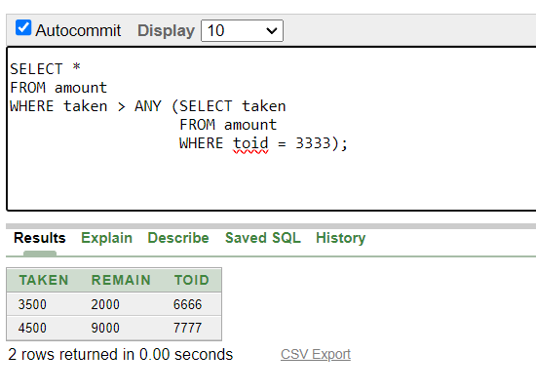
- S elect any customers who have taken more money than tokened 3333.

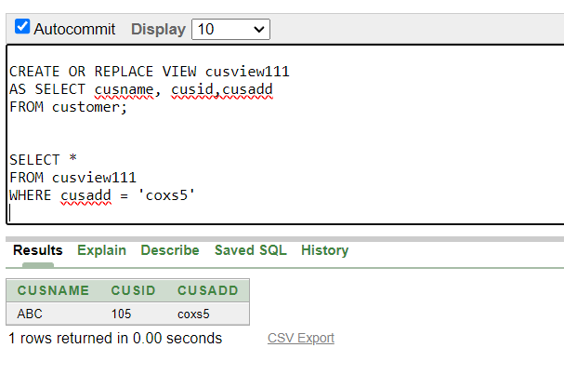
- Select all the customer who lives in COXS%

- Find out all the machines id, bankid.
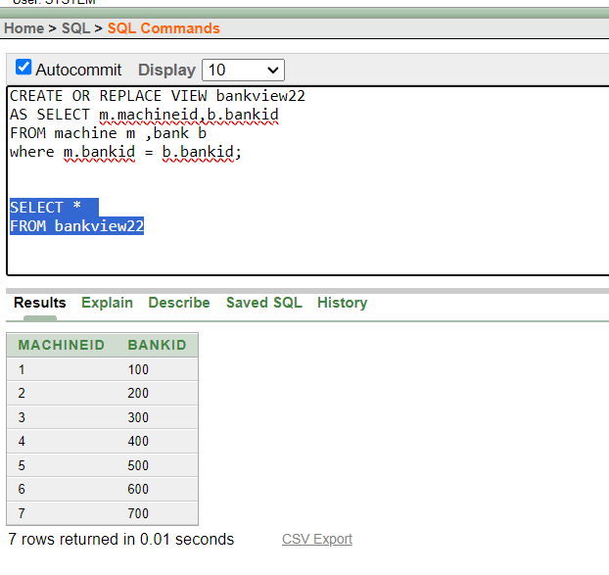
- Show self join in madd table
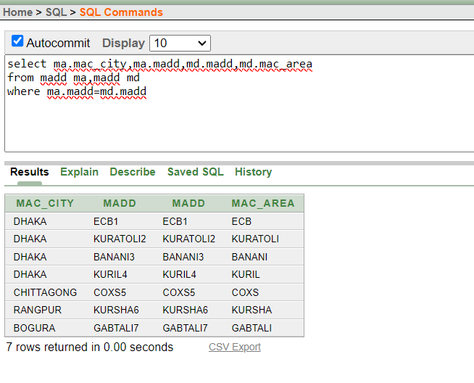
- Show equi join between machine and madd table

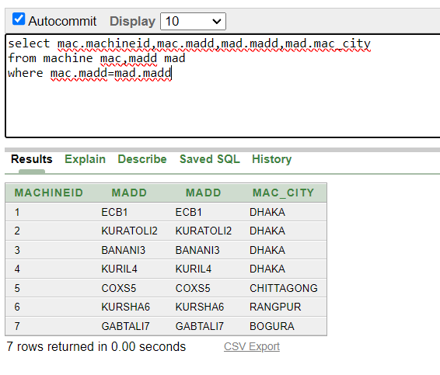
- Show outer join between bank and account.
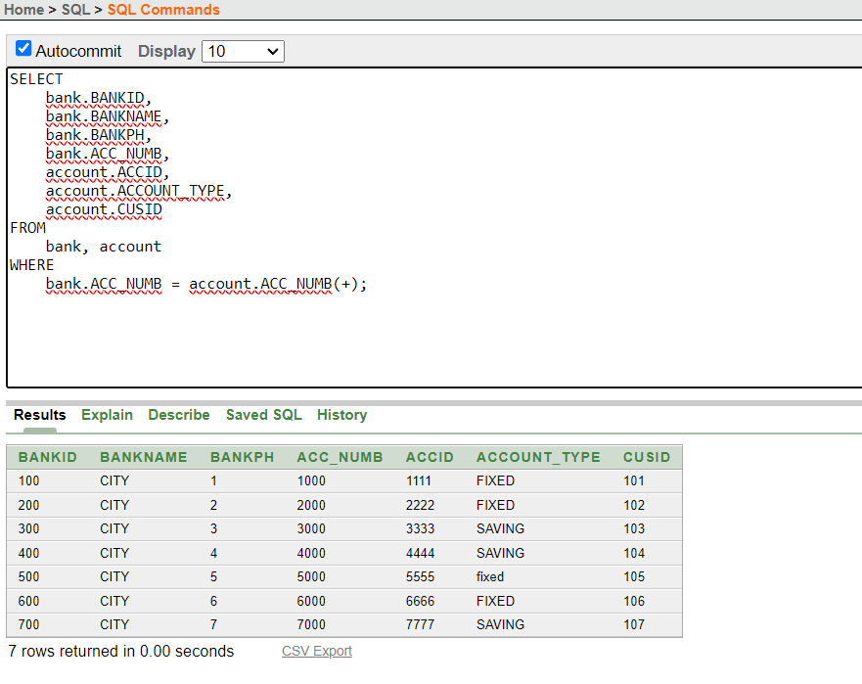

JOINING:
1.23-52178-2:
A. First, I install Xampp Server,VSCode and Download mysql-connector-java-8.0.28.jar.
B. I open Xampp server from Xampp control panel then start Apache and MySQL module then go to phpMyAdmin. There I create a Database by name “CUSTOMER” and create a table that name “CUSTOMER” then I insert Some values in it.
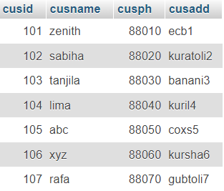

C. After creating the Database and table I open VSCode and create a project there. Then I added the mysql-connector-java-8.0.28.jar as a library. Then inside the main file, I write code to connect the Database that I create through the Xampp.
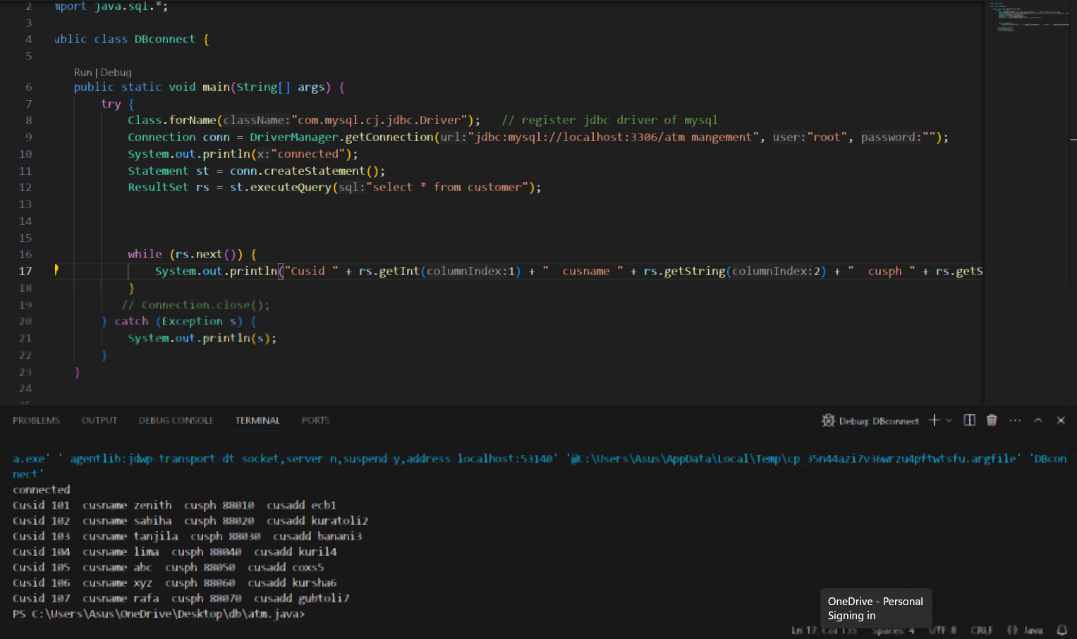

2.23-50408-1:

A. First, I install Xampp Server,VSCode and Download mysql-connector-java-8.0.28.jar.
B. I open Xampp server from Xampp control panel then start Apache and MySQL module then go to phpMyAdmin. There I create a Database by name “ACCOUNT” and create a table that name “ACCOUNT” then I insert Some values in it.

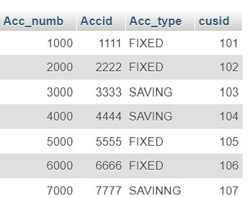

C. After creating the Database and table I open VSCode and create a project there. Then I added the mysql-connector-java-8.0.28.jar as a library. Then inside the main file, I write code to connect the Database that I create through the Xampp.

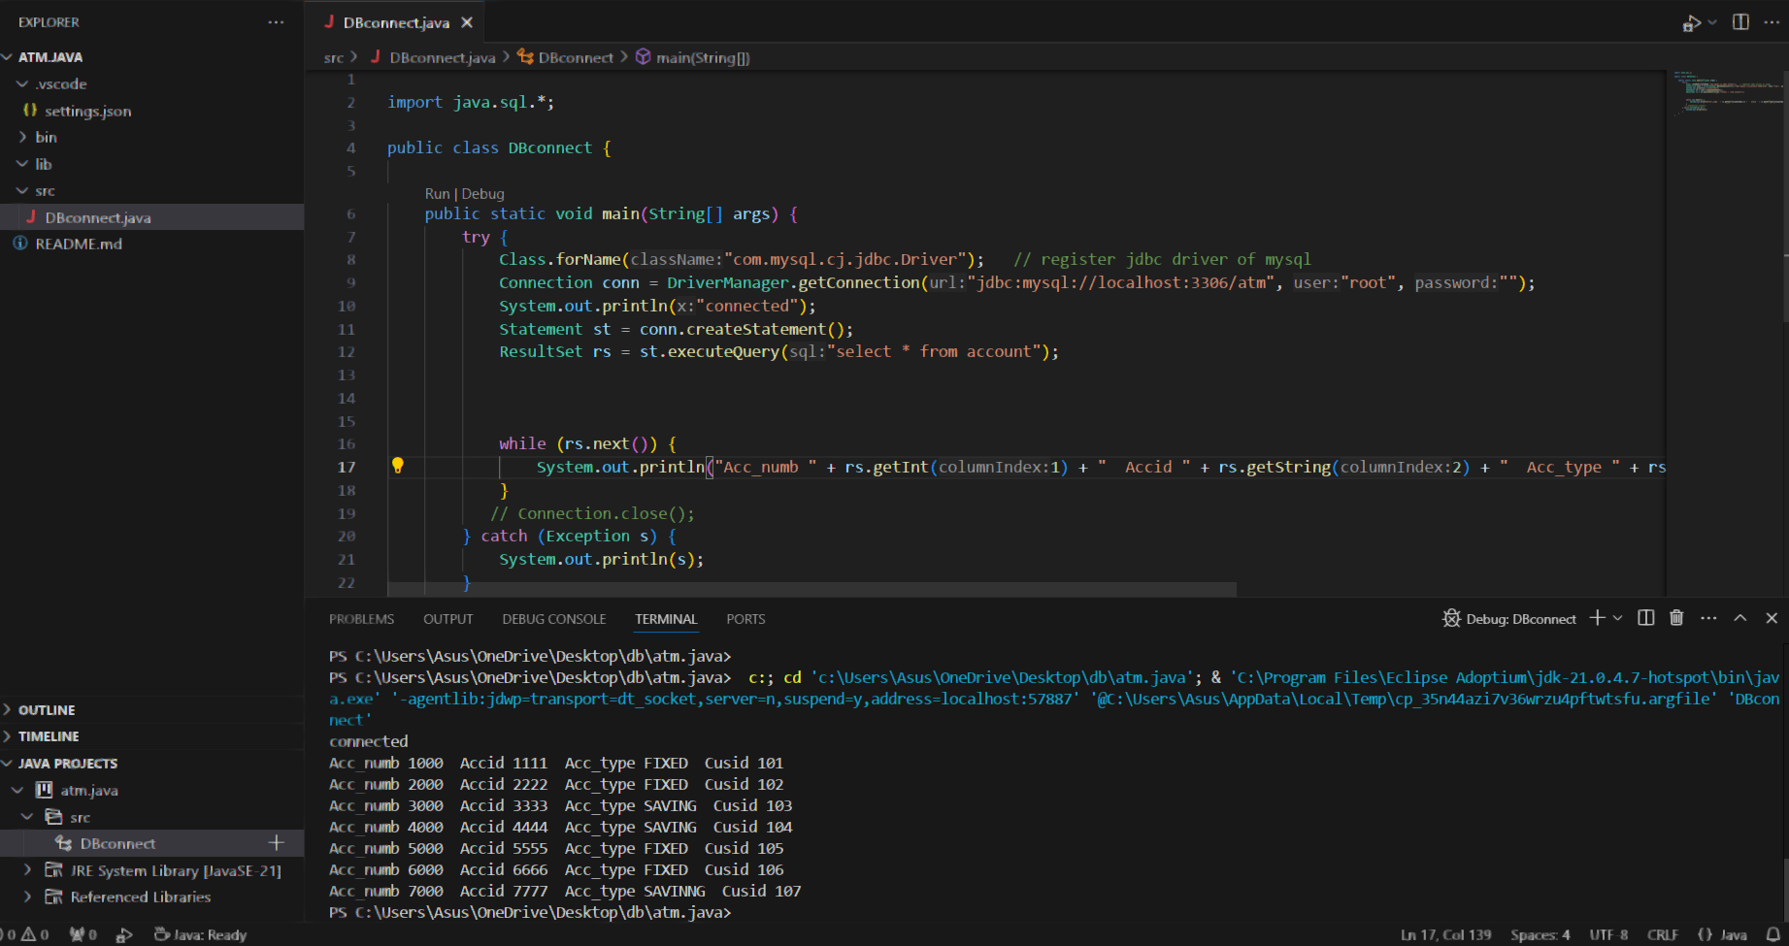

3.22-48088-2:
A.First of all, I downloaded the MySQL java connector(jar file). Then I installed the XAMPP server. After that from the XAMPP control UI, I started both Apache and MySQL actions. Then I created a database named “bankph” inside of MySQL and in that database created a table named “bankph”. Also, I inserted some values in the table.
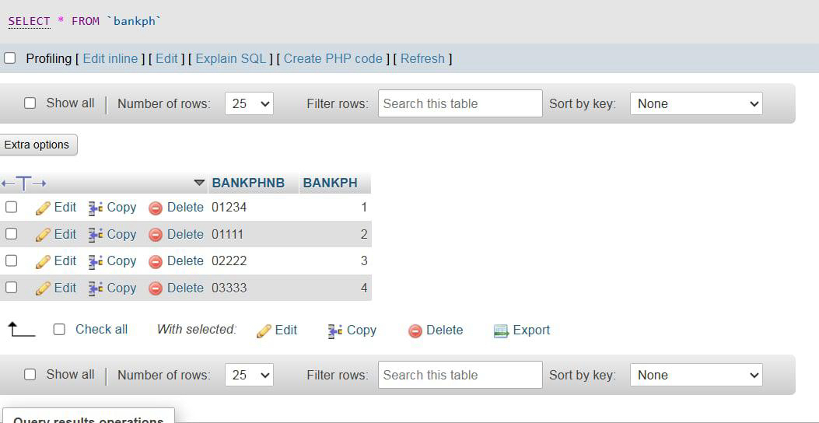
B. After that, I downloaded VS code. . Then I connected the database with this
java project and added the jar library. Then I created a statement and a ResultSet
to execute a simple query. Then with a while loop I printed all the values of the " bankph " table.
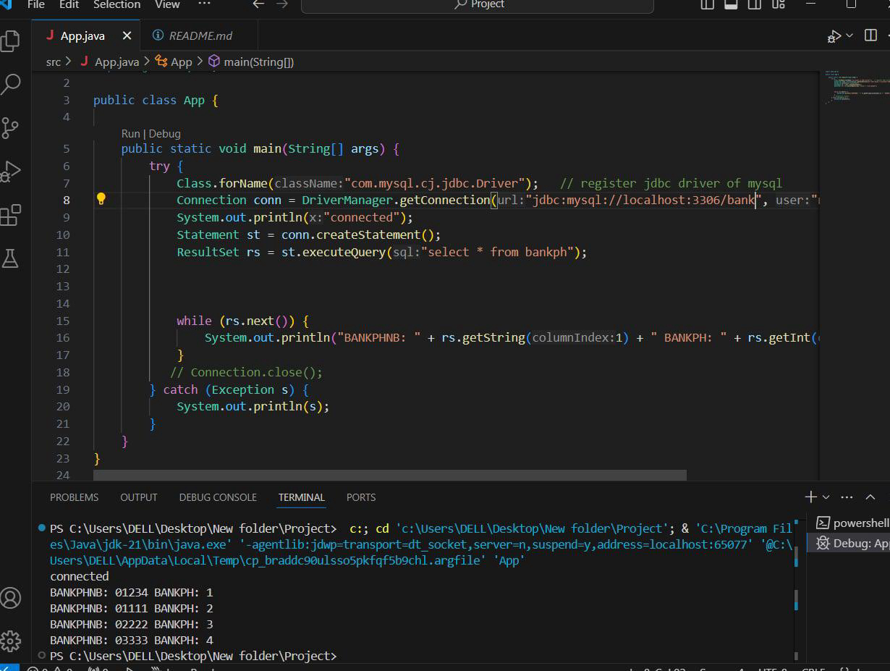

4.23-52194-2:

A.First of all, I downloaded the MySQL java connector(jar file). Then I installed the XAMPP server. After that from the XAMPP control UI, I started both Apache and MySQL actions. Then I created a database named “Machine” inside of MySQL and in that database created a table named “machine”. Also, I inserted some values in the table. 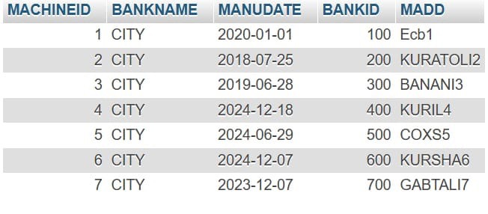

B. After that, I downloaded VS code. . Then I connected the database with this
java project and added the jar library. Then I created a statement and a ResultSet
to execute a simple query. Then with a while loop I printed all the values of the " machine " table.
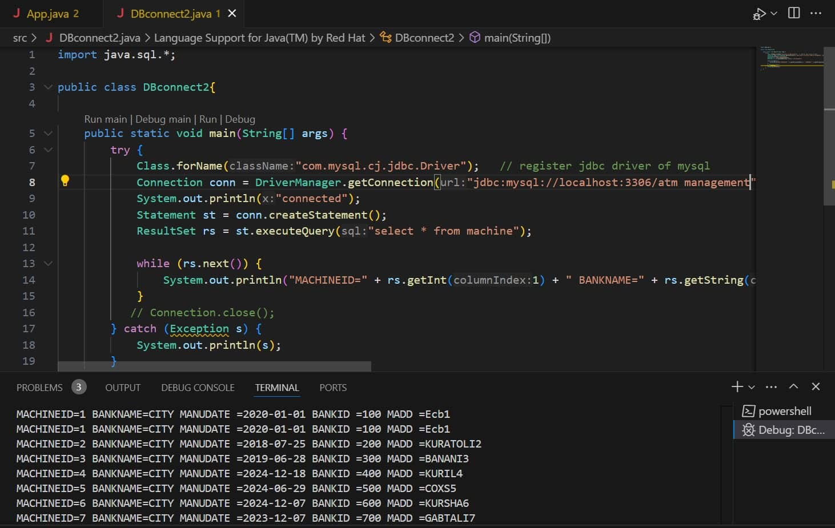

THANK YOU

